Filters Applied to ENCODE Data
For the study on using ENCODE data to find promoters, “filter” function of the UCSC Table Browser was used to limit the data retrieved to score ranges that were more meaningful. The thresholds, listed in Table S1, were determined in several ways. Only functional promoters score above zero, and an ad hoc threshold of 100 (slightly less than average) was selected. The thresholds for the ChIP on chip data for RNA polymerase II and TAF1 were selected by inspection: most of the striking peaks exceed a score of 2, whereas signals below 2 looked like noise. Both the MCS intervals (from the binMCS95 table) and the phastConsElements have already been limited to the top 5% of the genome. The threshold for the RP scores was determined by calibration studies on a reference set of regulatory elements in the HBB complex (King et al. 2005). All DNAse I hypersensitive sites were collected (no threshold).

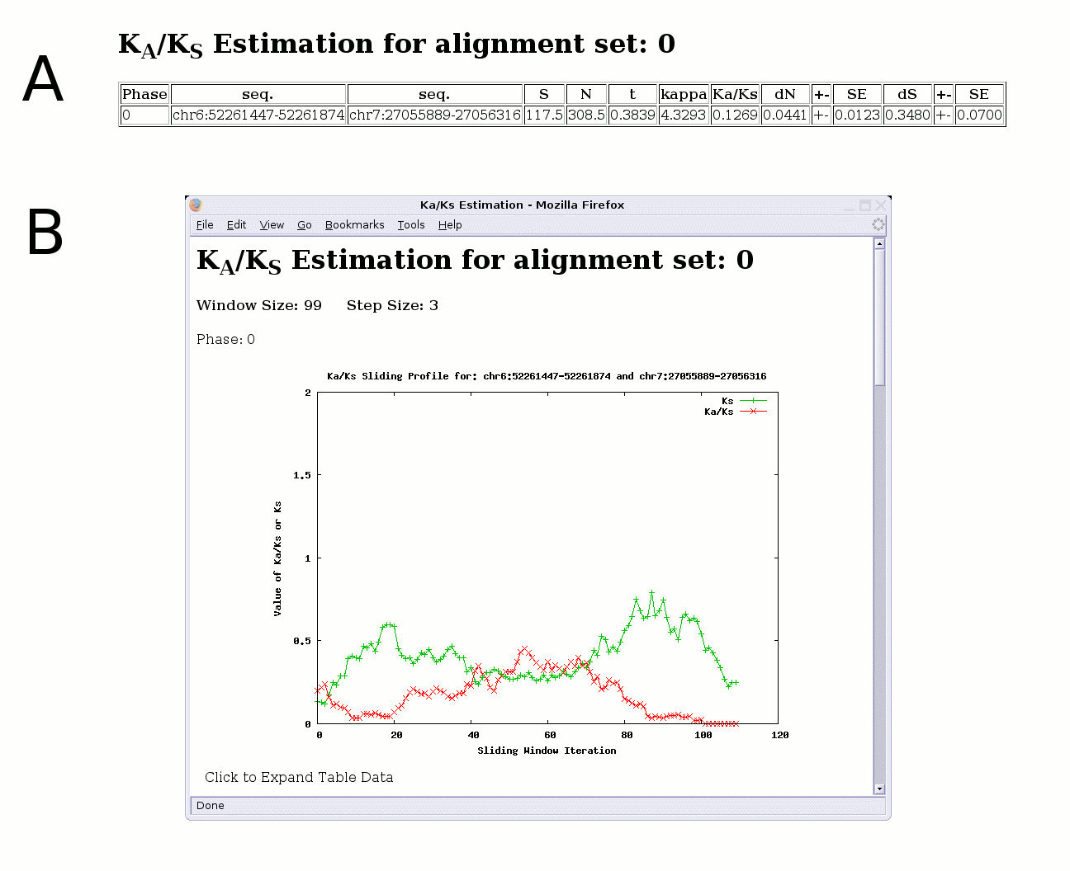
Figure S1. Results of (A) traditional and (B) sliding window K_{A} and K_{S} estimations for the first protein-coding exon of the human EVX-1 gene vs. its ortholog in mouse. The central part of the graph shows elevated K_{A}/K_{S} values (approaching 0.5), which may be indicative of adaptive evolution acting on that section of the gene.
S = # synonymous sites, N = # non-synonymous sites, t = # nucleotide substitutions per codon, kappa = transition/transversion rate ratio, dN = # non-synonymous substitutions per non-synonymous site, dS = # synonymous substitutions per synonymous site, SE = standard error of the estimation. To generate these results, the user requests the protein coding exons for this gene (located at chr7:27,055,661-27,059,432; hg17 assembly) from the Table Browser; three regions, corresponding to three coding exons, are returned to Galaxy. Next the alignment retriever tool is used to extract orthologous regions with mouse (mm5 assembly) corresponding to these exons. Once the alignment has been obtained, the user chooses the K_{A}/K_{S} tool and is able to select between a standard analysis or a sliding window approach. The sliding window interface allows the user to specify the window size and step size (meaningful defaults are provided). A “Click to Expand Table Data” link in the sliding window analysis display allows the user to view the K_{A}, K_{S}, and K_{A}/K_{S} values used to generate the graph. The user is also able to have the data returned directly to Galaxy as an extended BED file for further analysis.

Table S1. Thresholds chosen for properties of genomic intervals^{A}
Property | Track | Range for ENCODE | Mean | Threshold
Promoter | Promoter/Stanford | 0 to 934 | 134 | 100
DNAse HSs | DNaseI-HS/NHGRI | n/a | n/a | n/a
Bound by RNA polymerase II | ChIP/LI Pol2 HeLa | 0 to 16 | 0.73 | 2.0
Bound by TAF1 | ChIP/LI TAF1 HeLa | 0 to 16 | 0.46 | 2.0
MCS | MCSs (5%) | 200 to 1000 | 821 | 200
PhastConsElements | Most Conserved | 137 to 899 | 320 | 137
RP | 3x Reg Potential | -0.089 to 0.065 | -0.0012 | 0.001

^{A}Abbreviations are DNAse I HSs = DNAse hypersensitive sites, MCS = multispecies conserved sequence, phastConsElements = DNA sequence whose multispecies alignment falls within the 5% most highly conserved genomic intervals in human, RP = regulatory potential.

